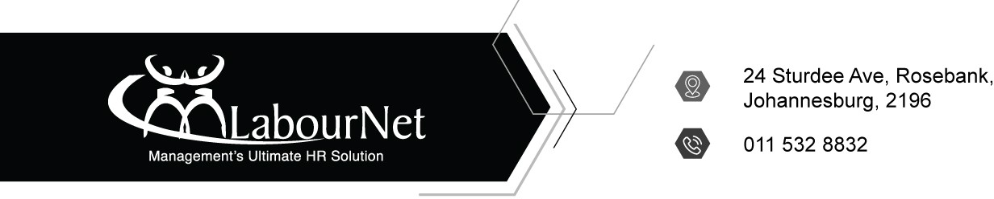

Dear valued client

Re: LabourNet –Information Compliance client: PAIA report to Information Regulator

- Kindly note that in line with the request from the Information Regulator, in terms of Section 83(4) of the Promotion of Access to Information Act No. 2 of 2000. We are requested to ensure that we submit the PAIA reports to the Information Regulator by the 30th of June 2023.
  - Kindly be advised that this request is mandatory, and failure to comply with same may result in the Information Regulator effecting an Audit/investigation into your company’s compliance status.
- The PAIA Report covers the period from 30th April 2022 to 31st March 2023.
  - The report covers only the requests formally made in terms of the PAIA manual. In the event that you have not received any PAIA request, please proceed to indicate “0” in the link below.
  - In the event that you have had PAIA request/s, kindly contact me for further assistance in completing the said submission.
- We will assist in the submission to ensure that this is done according to the standards put/set forth by the Information Regulator.
- Kindly follow the link below as it takes you to a questionnaire that contains the information that will be needed by the submission of the said PAIA report.
- Last be reminded that I as your consultant am here for any query, assistance that you might need.

Please Click HERE to complete the form.

Yours Faithfully Desmond D Ndlovu
Information Compliance Consultant
Industrial Relations | Occupational Health & Safety | Payroll | Skills Development | Information Compliance | Employment Equity | B-BBEE | Training Management | Litigation

www.labournet.com

